Supply Chain Analysis
Project Overview
This project focuses on analysing supply chain operations to identify trends in product sales, inventory levels, manufacturing costs, supplier performance, product quality, and transportation efficiency. Using SQL and Power BI, the project explores key business metrics to uncover insights that can help businesses improve inventory management, control costs, monitor defects, and make data-driven operational decisions.
Objectives
- Analyse sales performance and revenue across product categories.
- Identify products with low or zero inventory to support restocking decisions.
- Evaluate supplier performance based on manufacturing costs and defect rates.
- Compare transportation modes to identify those with lower average costs.
- Examine relationships between product prices, sales volume, shipping costs, and delivery lead times.
- Assess product inspection results to understand quality-control performance.

Tools and Technologies
- SQL: Data analysis, aggregation, filtering, grouping, and business queries.
- Power BI: Data visualization, KPI reporting, and interactive dashboards.
- Excel/CSV: Dataset storage and initial data inspection.
Expected Business Value
The analysis aims to help businesses make informed decisions about inventory replenishment, supplier selection, transportation planning, cost optimization, and quality control.
Dataset Summary:
- 100 rows
- 24 columns
- No missing data
Exploratory Data Analysis using Python
We began with data preparation and cleaning in Python:
- Data Loading: Imported the dataset using pandas.
- Initial Exploration: Used df.info() to check structure and .describe() for summary statistics.
- df.info()

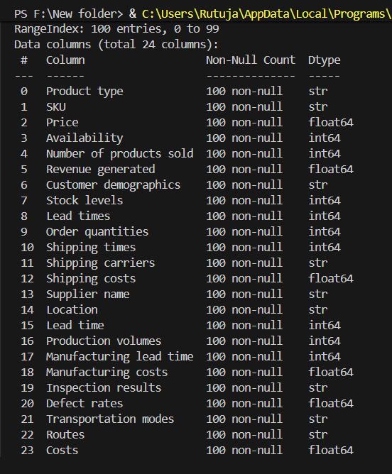
df.describe():
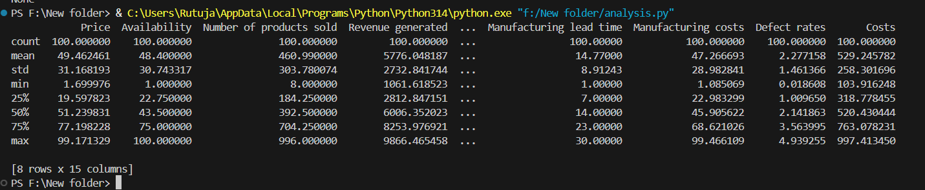

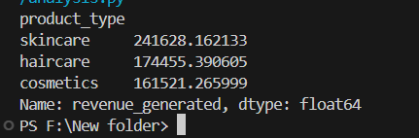
Product wise revenue generated:
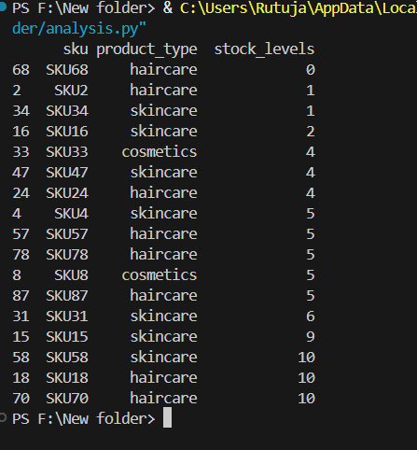
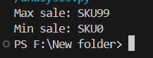
min and max sales with respect to SKU

stock levels as per product types:

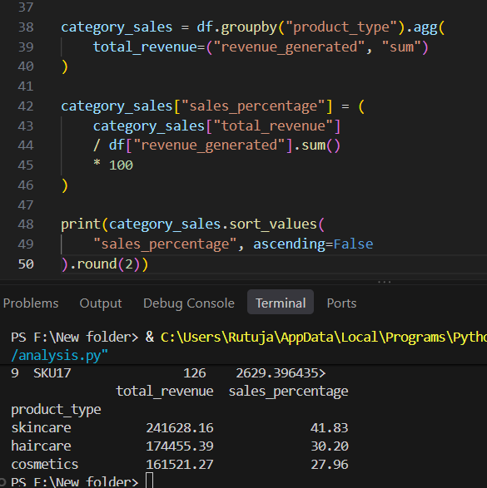
Analysis of revenue generated and products sold by product type and stock level remaining :
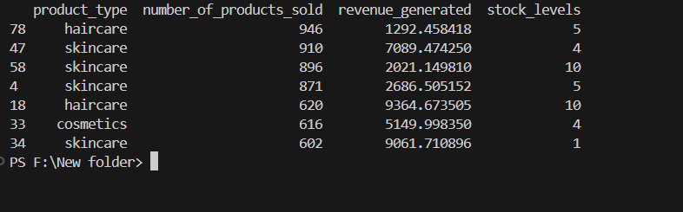
Stock levels by product type :
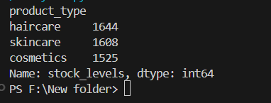

Defect rates by supplier names :
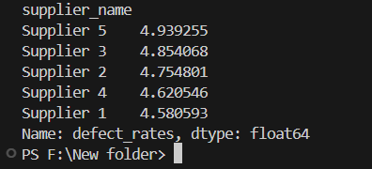

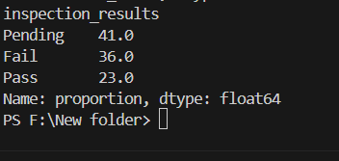
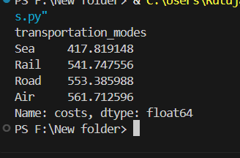
costs as per transportation modes:

deliveries inspection results like pending fail and pass:

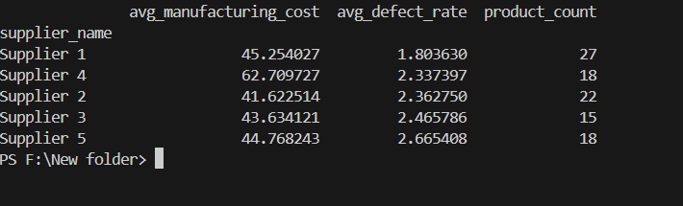
supplier has the lowest average manufacturing cost

- Data Analysis using SQL (Business Transactions)
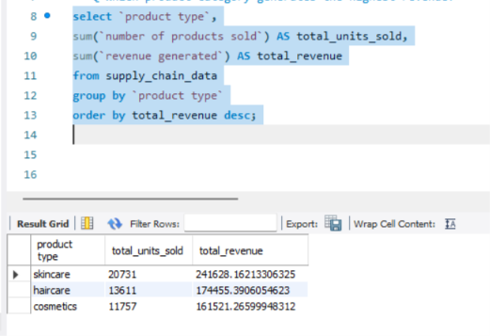
We performed structured analysis in MYSQL to answer key business questions:

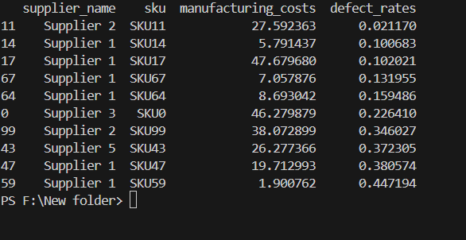
- total product sold and revenue generated:

- Most sell sku which generated more revenue

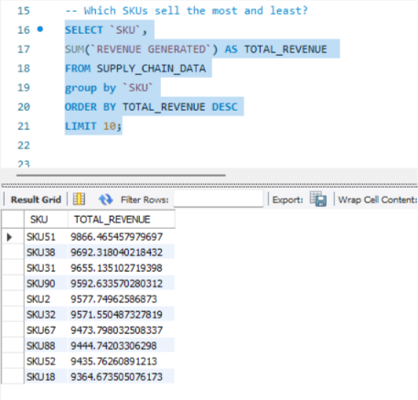
- high sale product but low recorded revneue

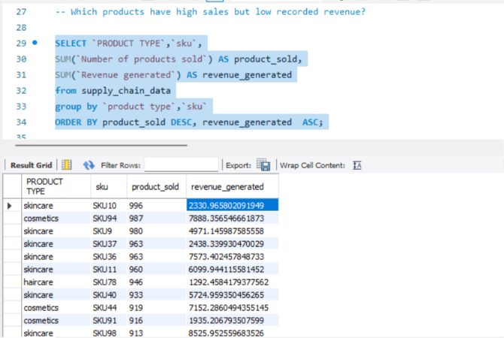

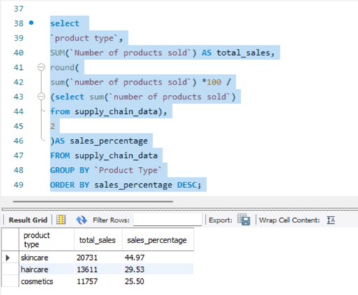
- sales percentage by product type :

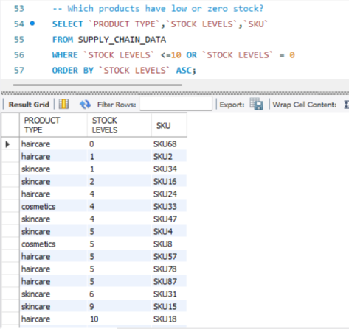
- products having low or zero stock levels:
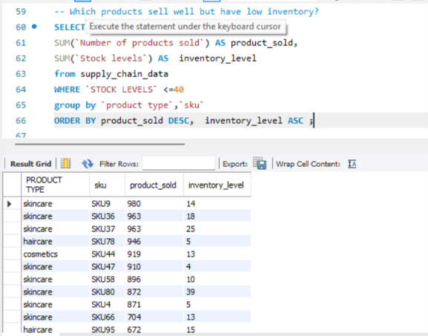
- products that sell well but has low inventory

- Transportation mode that has lowest average cost

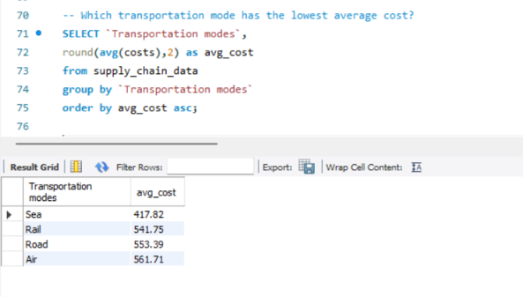
- Transportation route that has higher cost as compared to other
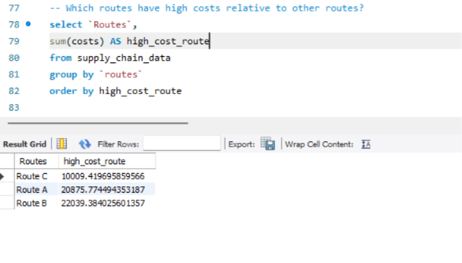
- Transportation route that has lowest average cost

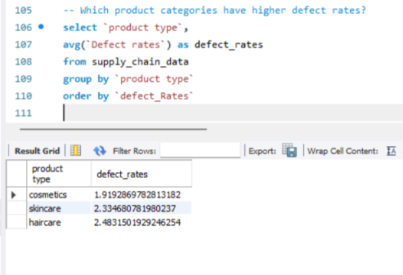
- product categories with highest defect rate

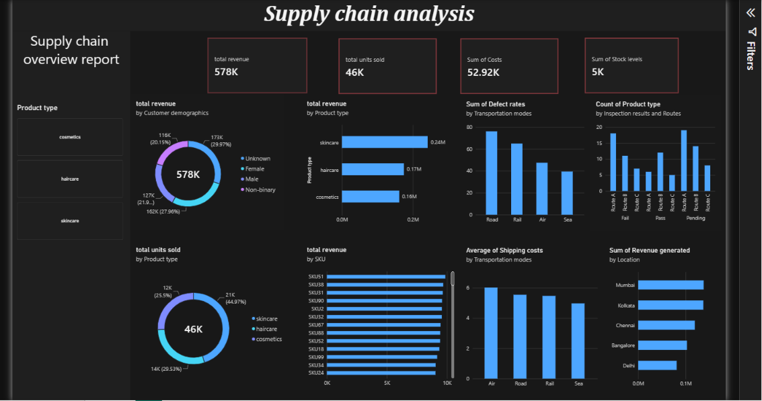
Dashboard:

Here are the key takeaways from the dashboard:
- Top Revenue Generator: Skincare leads total revenue ($0.24M / 41.5%) and sales volume (21K units / 45%).
- Logistics Bottleneck: Road transit carries the highest defect rate despite high shipping costs. Sea freight is the most cost-effective and reliable.
- Quality Control Issue: Route A experiences the highest count of failed inspections.
- Data Gap: 29.97% of revenue comes from "Unknown" customer demographics.
- Top Geographic Markets: Mumbai and Kolkata drive the highest overall revenue.
Strategic Recommendations
- Optimize Transport & Carrier Selection:
  - Audit Road transit providers to investigate the high defect rate (~78). Transition reliable high-volume shipments to Sea or Rail where viable to reduce both shipping costs and transit damage.
- Address Route A Quality Control:
  - Investigate Route A bottlenecks and handling protocols, as it consistently experiences peak failure counts during quality inspections.
- Capture Demographic Data:
  - Implement incentives (e.g., discounts, loyalty sign-ups) to reduce the 29.97% Unknown demographic share, enabling sharper targeted marketing campaigns.
- Capitalize on Regional Success:
  - Expand inventory allocation and targeted promotions in high-performing hubs (Mumbai and Kolkata) while evaluating sales strategy adjustments for lower-performing markets like Delhi.

